**7.1 Pythagorean Theorem Classwork & HW**

**Mild –** *Complete for an 8/10*

Find the value of y*.* Express in simplest radical form.

img%208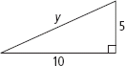

**2.**

**1.**

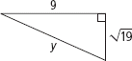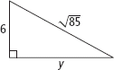

**4.**

**3.**

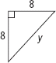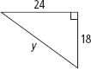

**6.**

**5.**

Is each triangle a right triangle? Explain.

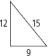

**8.**

**7.**

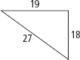

**Medium –** *Complete the Mild and this for a 9/10*

Find the value of x*.* Express in simplest radical form.

**1.**

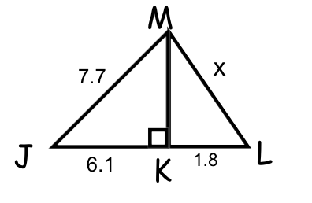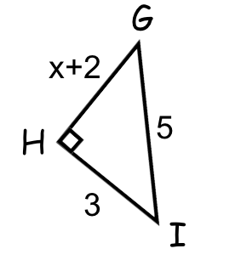

**2.**

Is each triangle a right triangle? Explain.

**4.**

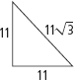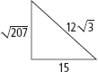

**3.**

A repairman leans the top of an 8-ft ladder against the top of a stone wall. The base of the ladder is 5.5 ft from the wall. About how tall is the wall? Round to the nearest tenth of a foot.

The playing surface of a football field is 300 ft long and 160 ft wide. If a player runs from one corner of the field to the opposite corner, how many feet does he run?

**6.**

**5.**

**Spicy –** *Complete the Mild, Medium, and this for a 10/10*

A square is drawn inside a circle so that its vertices touch the circle. If the  
radius of the circle is 15 cm, what is the perimeter of the square?

**2.**

A square has diagonal length 9 m. What is the side length of the square, to the nearest centimeter?

**1.**

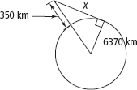

**3.**

The International Space Station orbits 350 km above  
Earth’s surface. Earth’s radius is about 6370 km. Use the  
Pythagorean Theorem to find the distance from the space  
station to Earth’s horizon. Round your answer to the nearest  
10 kilometers. (Diagram is not to scale.)